**DAY-26:**

Problem Statement: Socket Programming in C

Design and implement a reliable and efficient network communication system using socket programming in C to enable data exchange between two or more processes running on different machines over a network.

Specific Requirements:

Socket creation: Create appropriate socket descriptors for the desired communication protocol (TCP, UDP, etc.).

Address binding: Bind the created socket to a specific network address and port number for both client and server applications.

Connection establishment: Implement connection setup mechanisms (connect, accept) for TCP-based communication.

Data transfer: Develop functions for sending and receiving data over the established socket connection.

Error handling: Incorporate robust error handling mechanisms to address potential network issues and unexpected exceptions.

Concurrency: For server-side applications, consider handling multiple client connections concurrently using appropriate techniques (e.g., threading, forking).

Security: Implement appropriate security measures to protect data integrity and confidentiality (e.g., encryption, authentication).

Login authentication from Client to server 1:

**Server:**

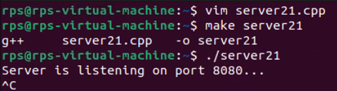

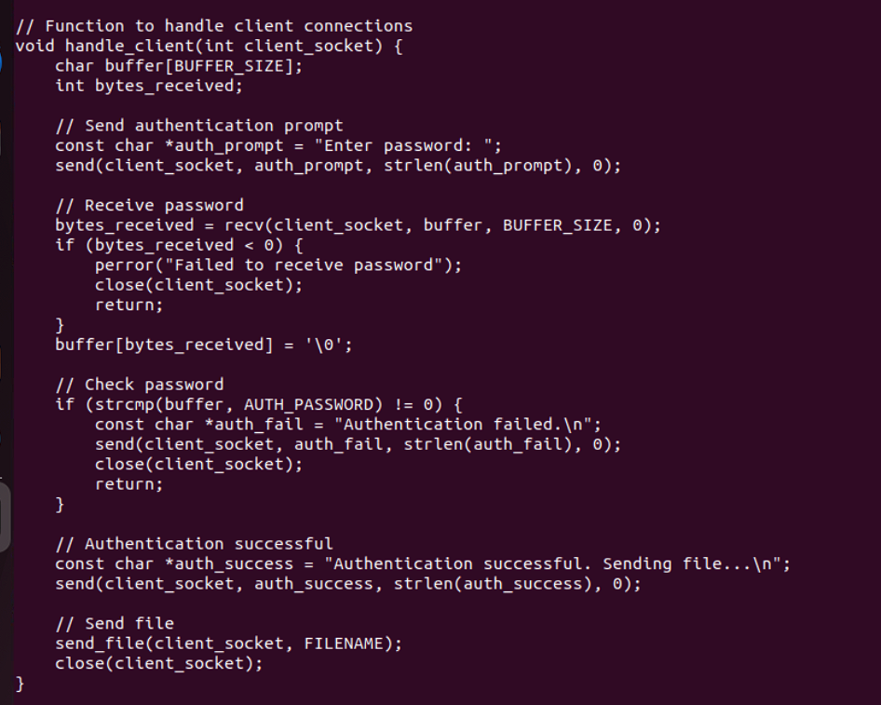

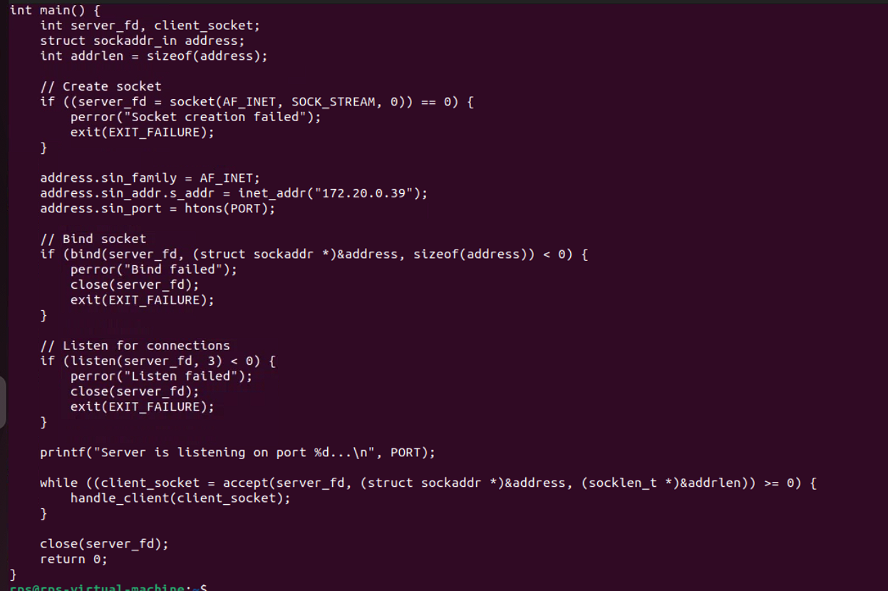

**Client:**

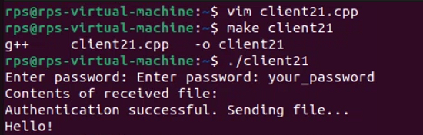

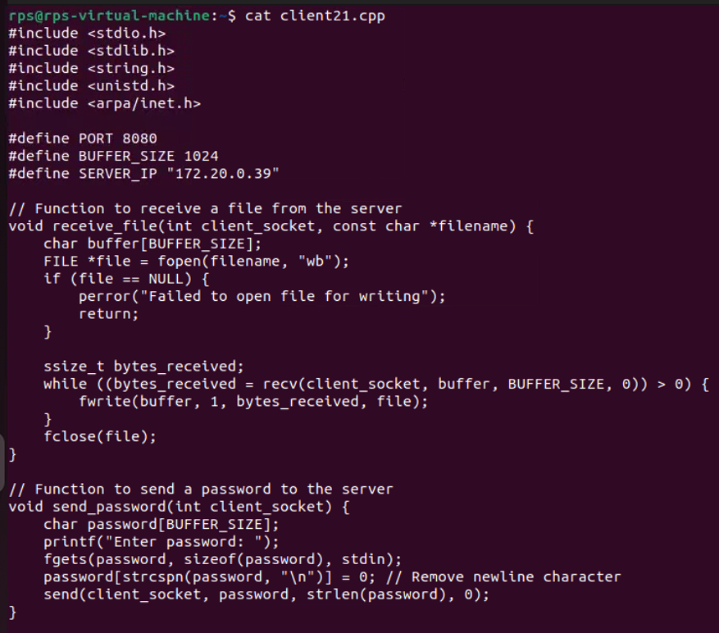

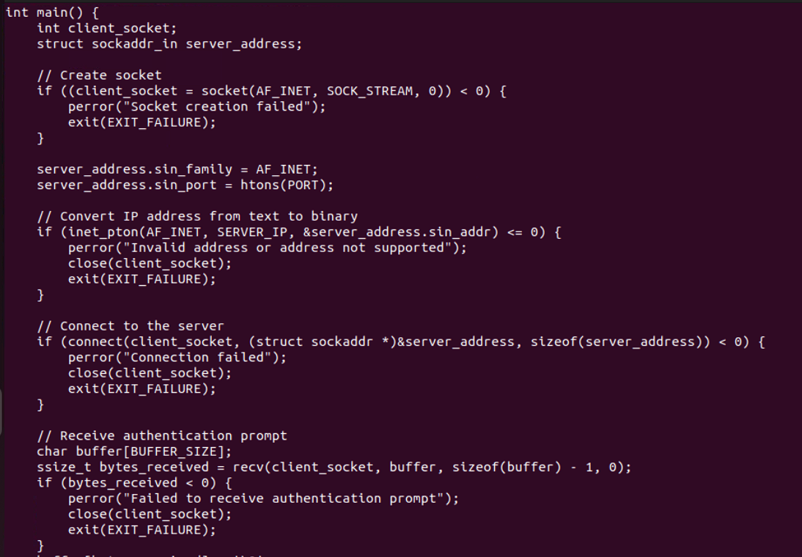

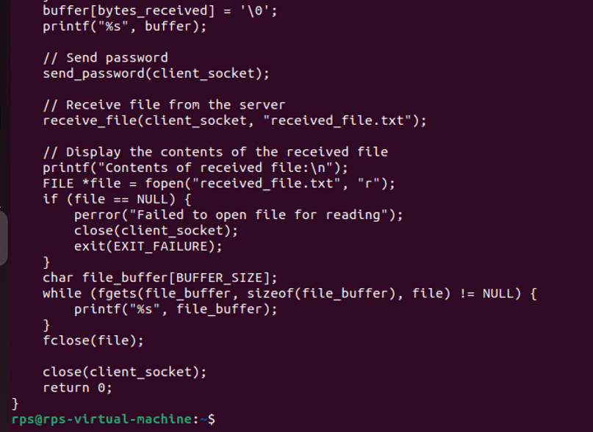

**IPC USING SOCKET**

**SERVER:**

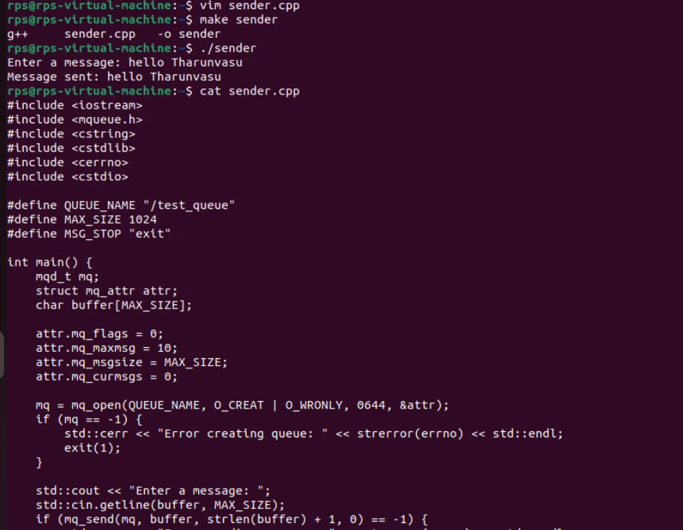

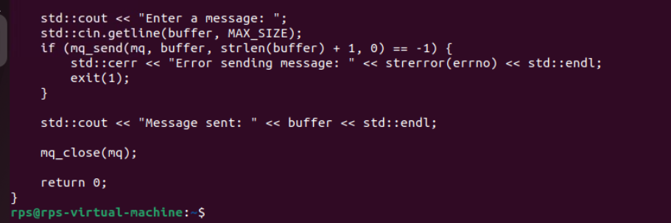

**CLIENT:**

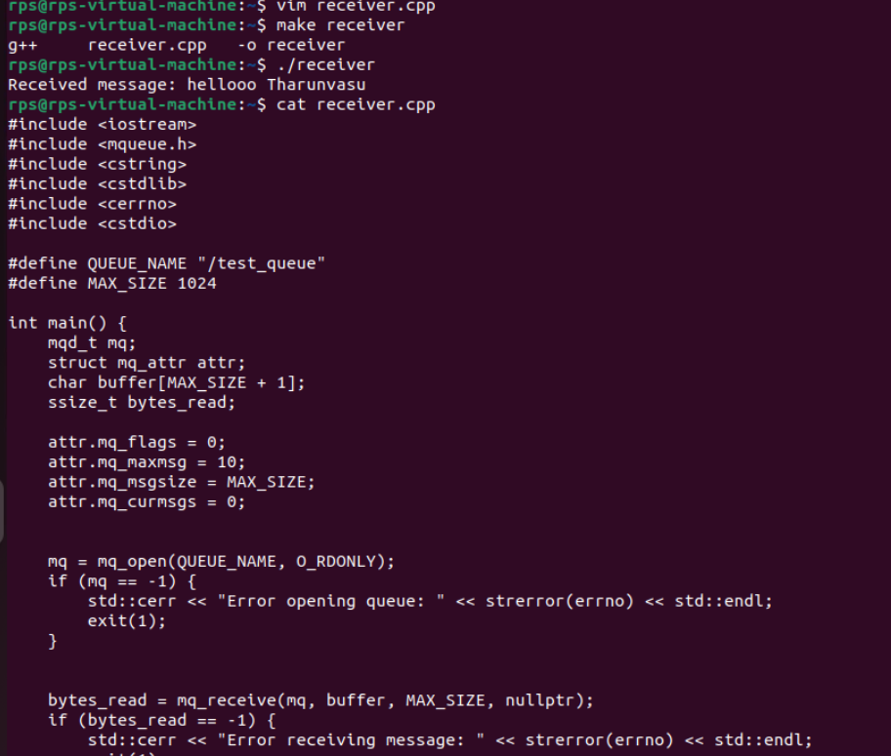

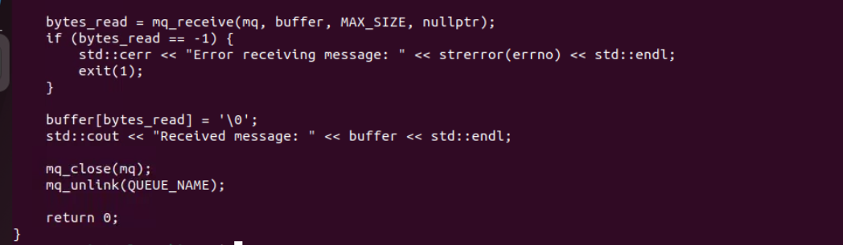

**MESSAGE QUEUE:**

**PROCESS 1**

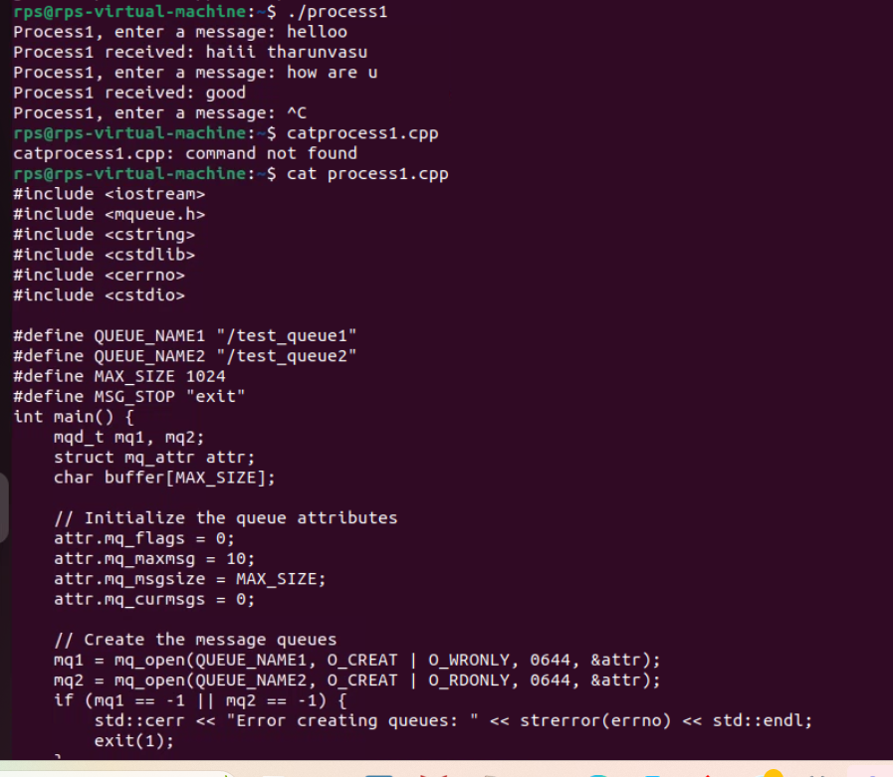

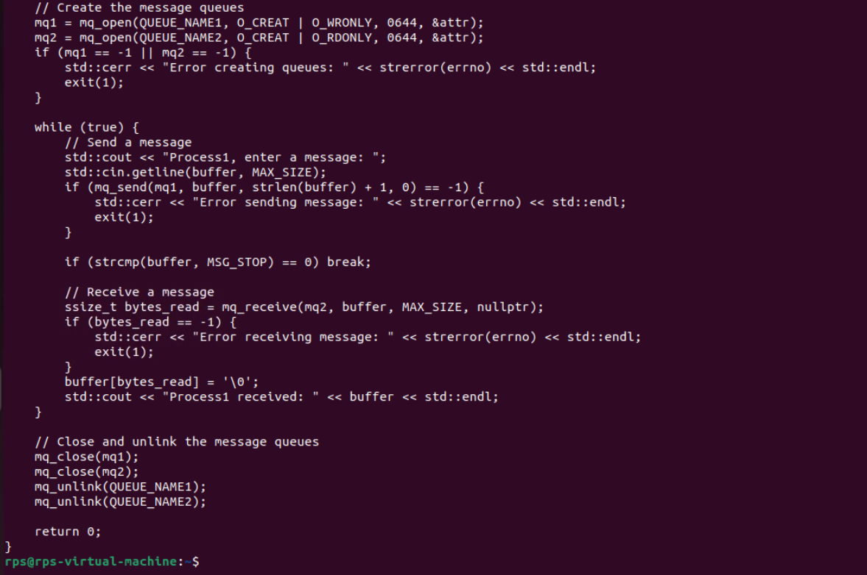

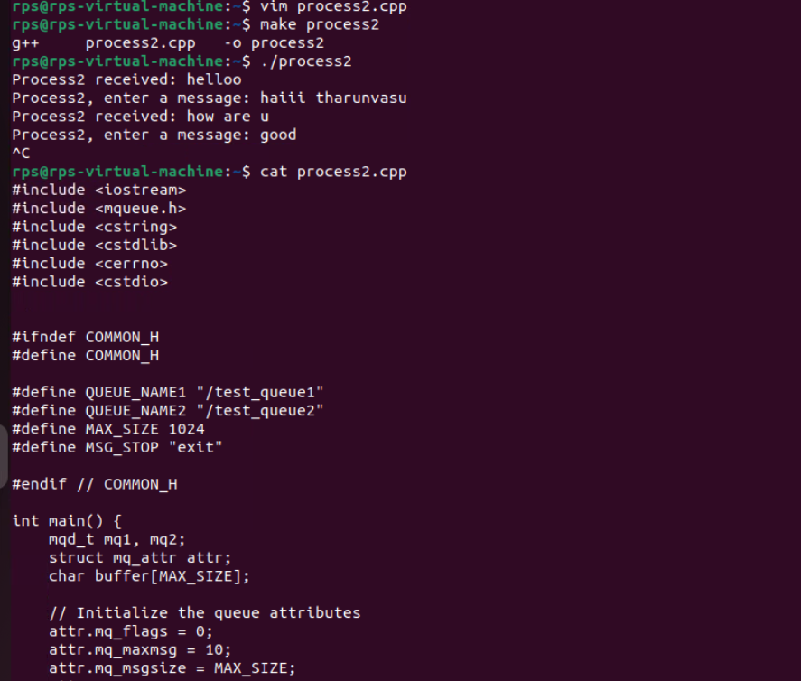

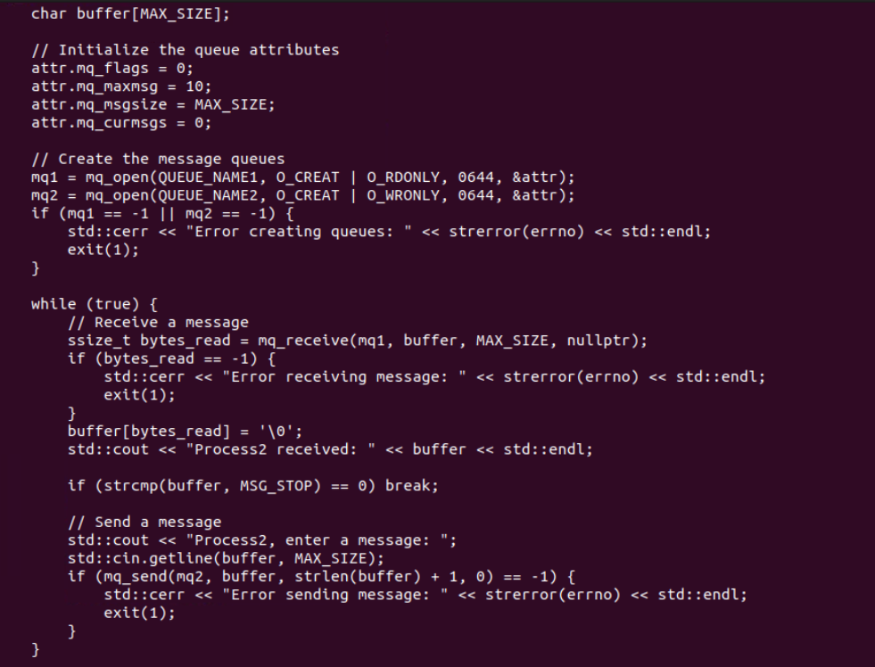

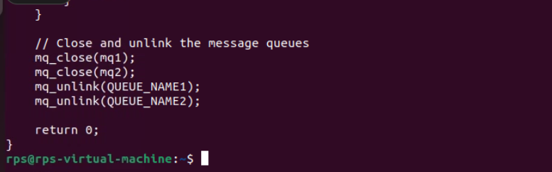

**SERVER:**

**PROCESS 1:**

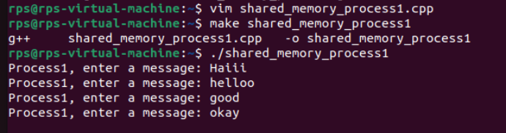

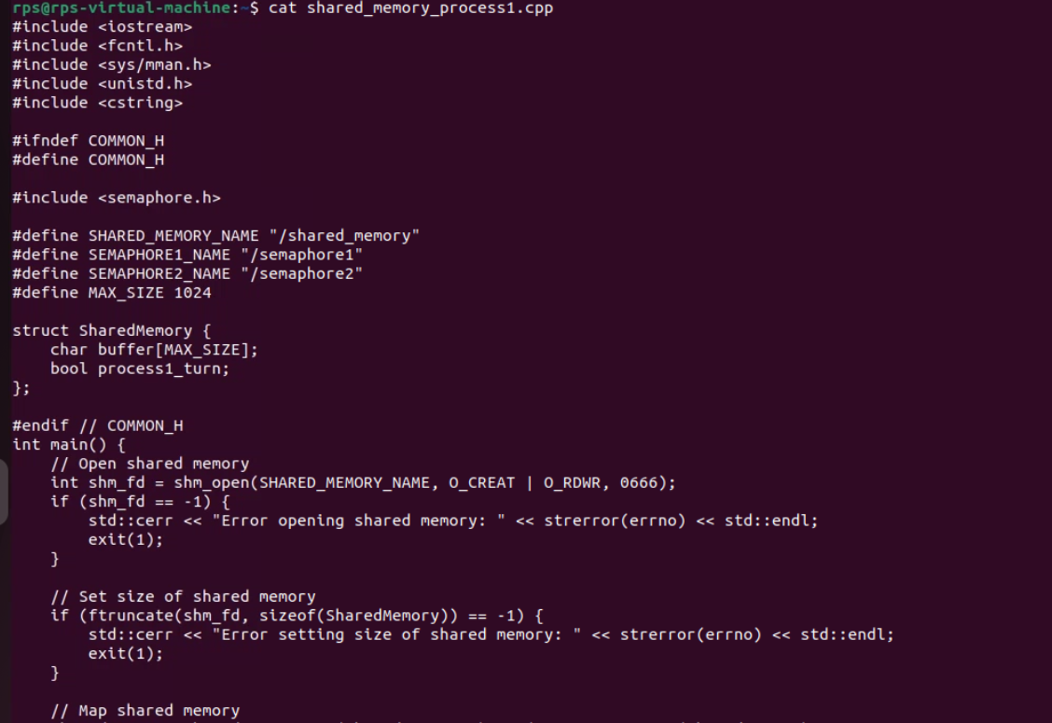

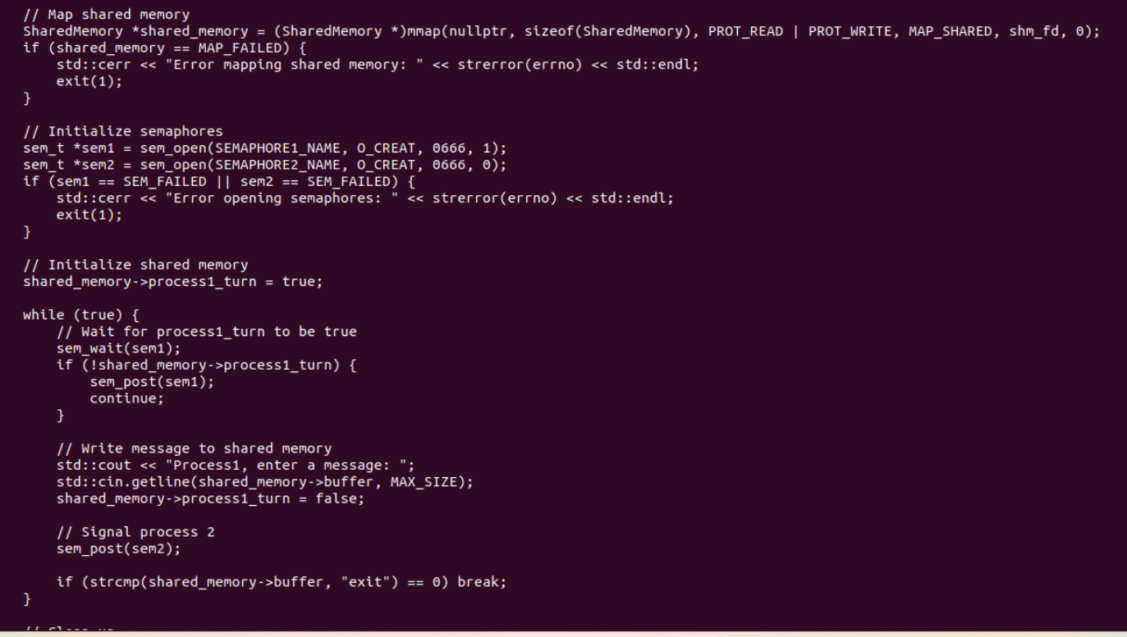

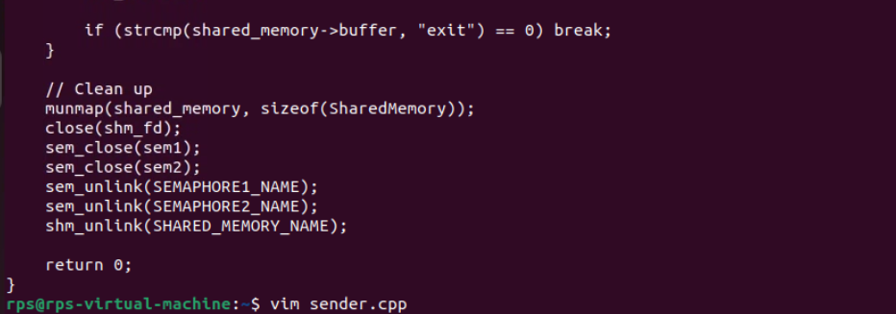

**CLIENT :**

**PROCESS 2:**

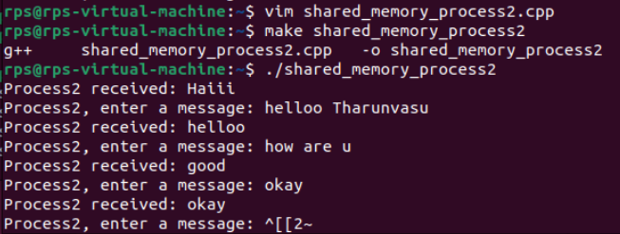

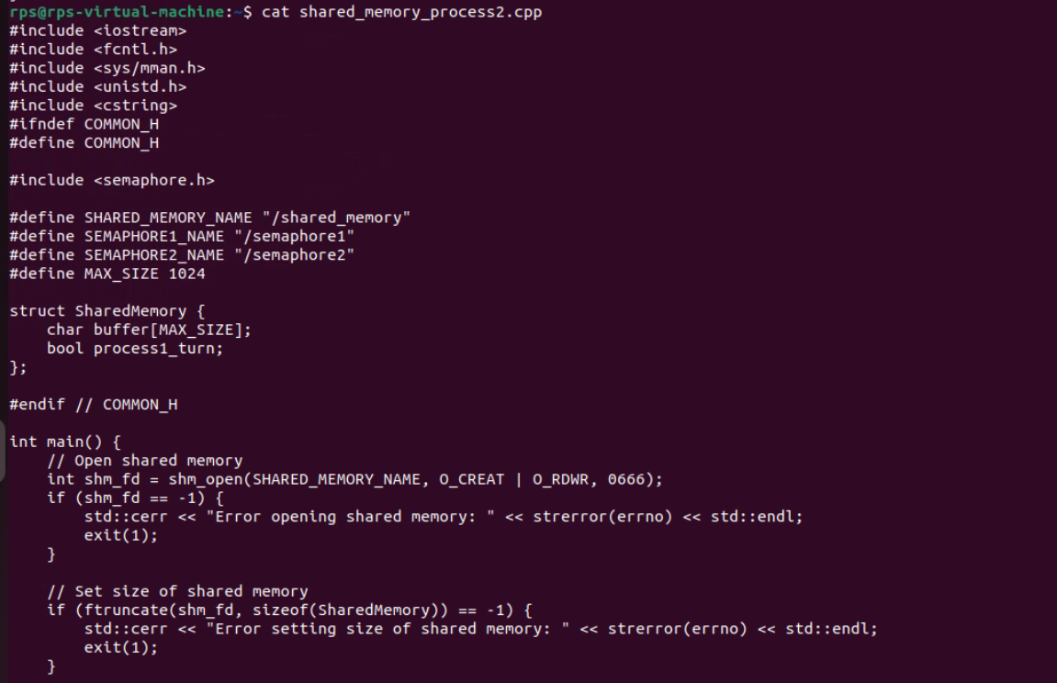

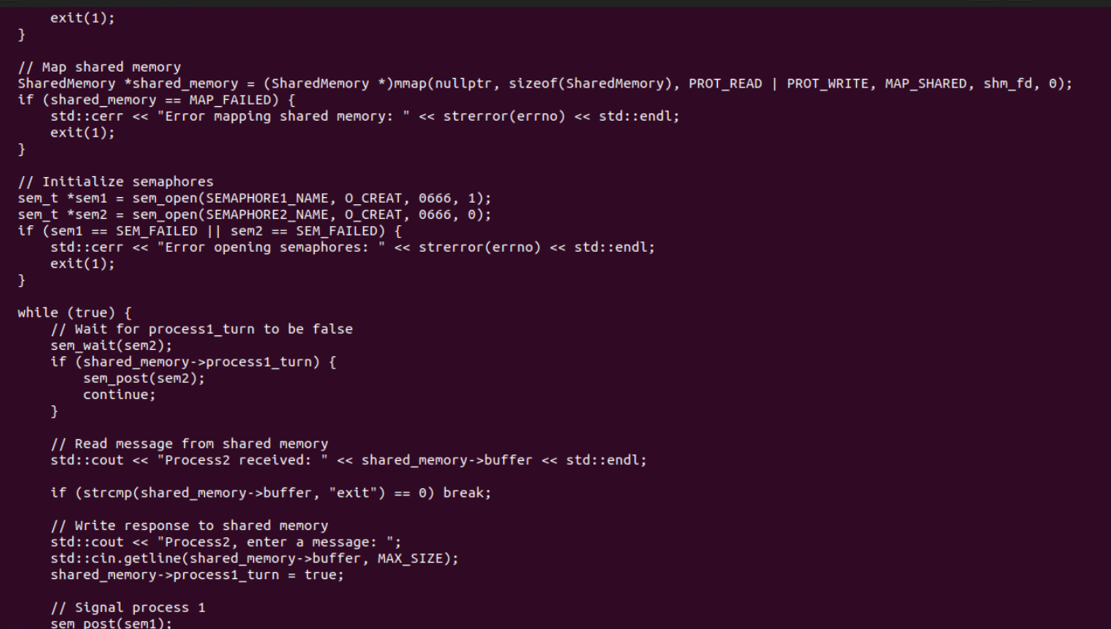

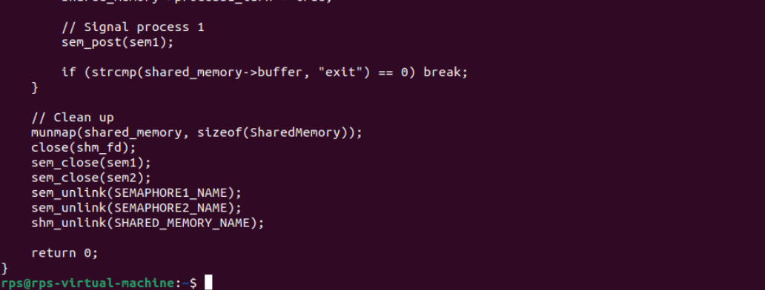

**PIPE 1:**

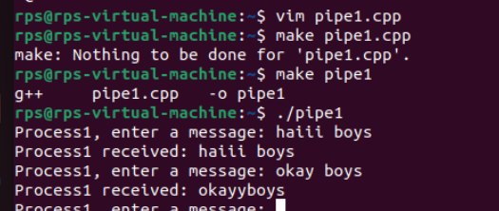

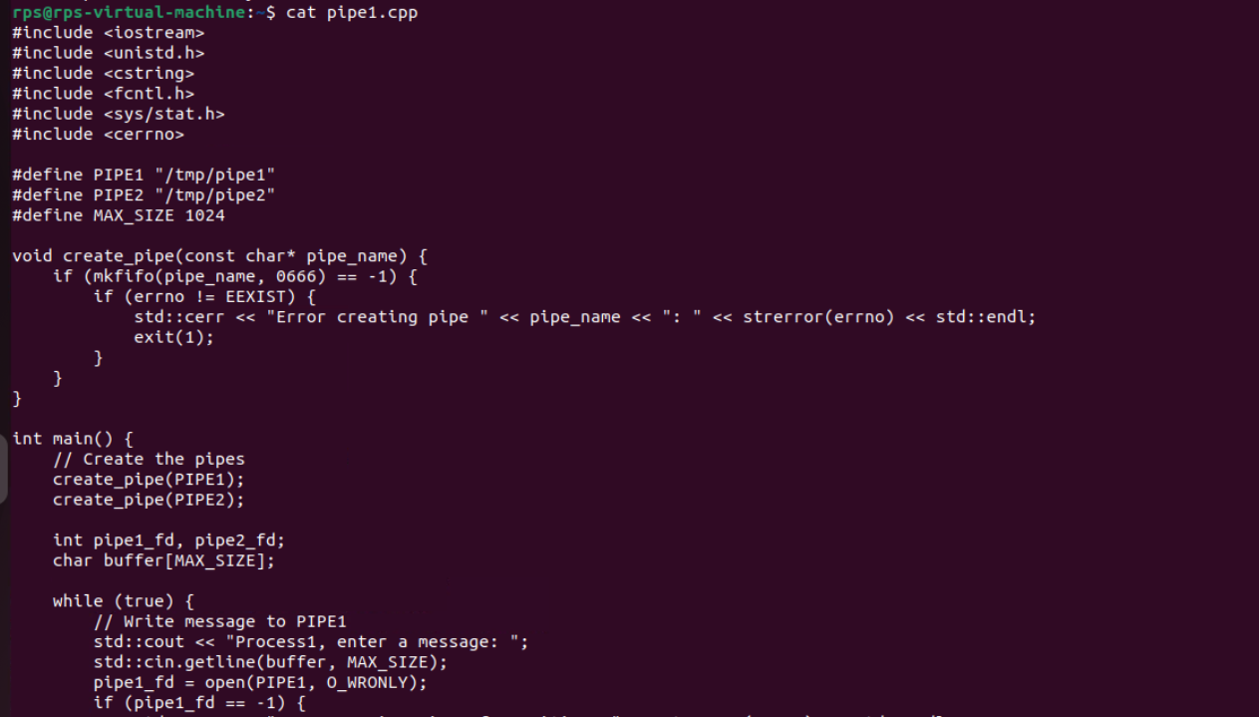

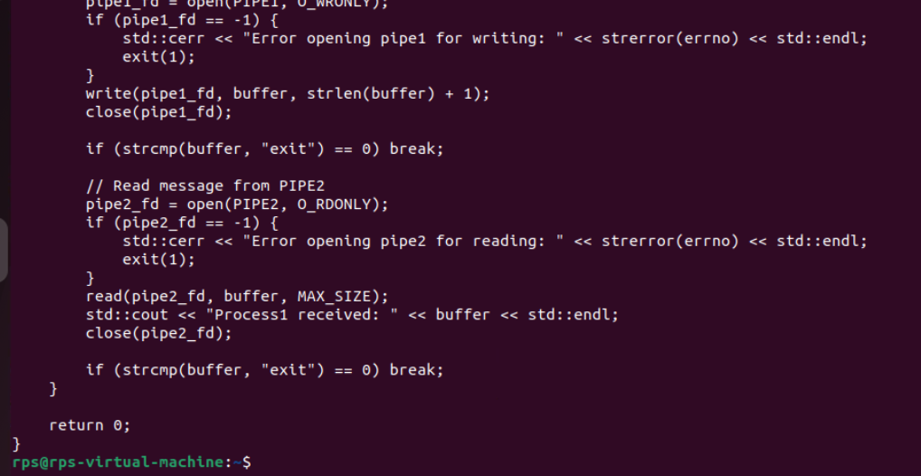

**PIPE 2:**

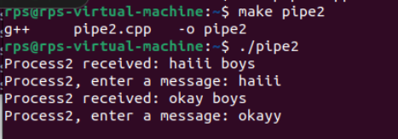

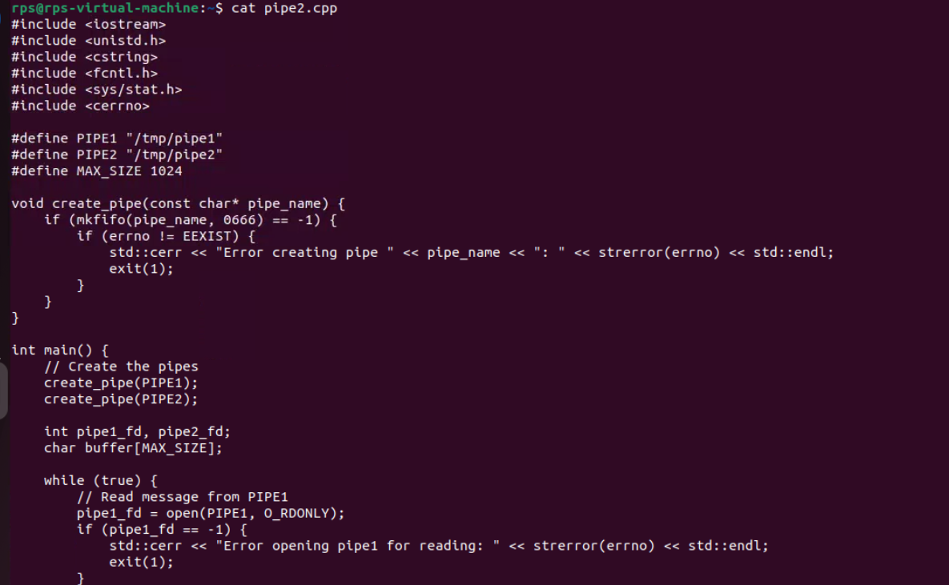

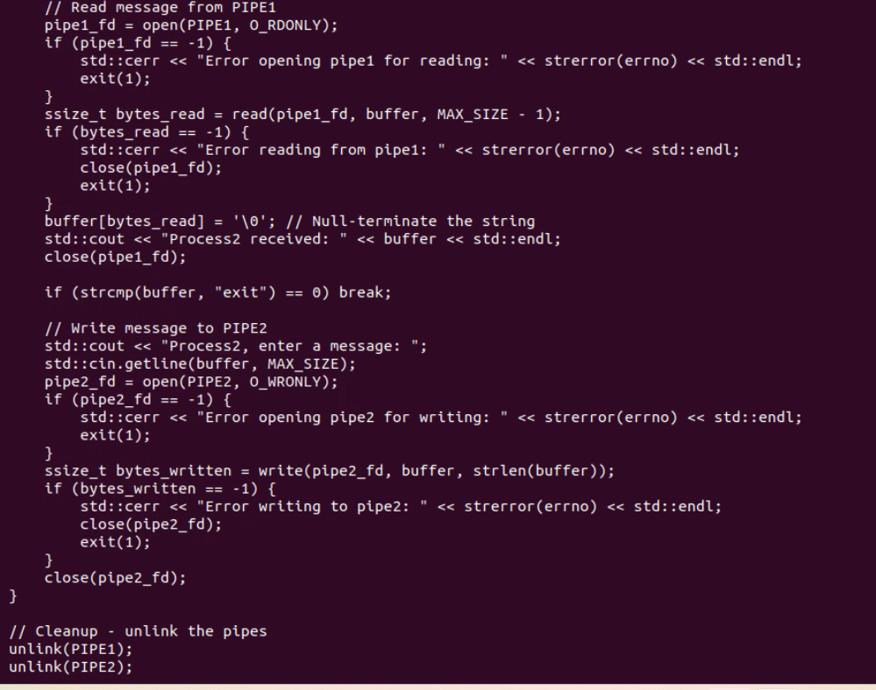

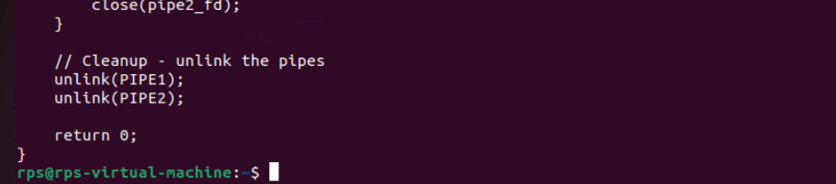

**Fork and Child Process:**

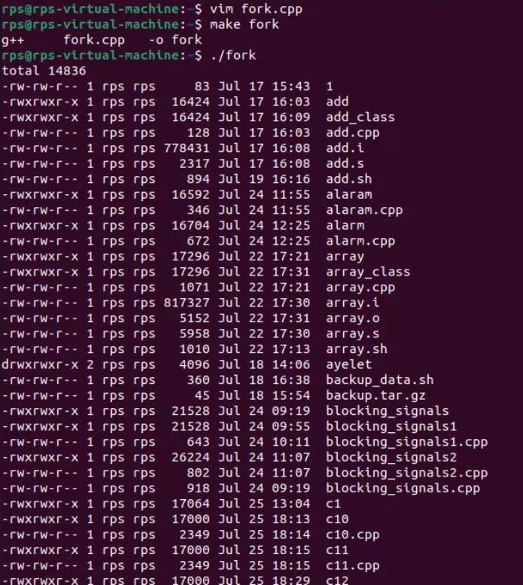

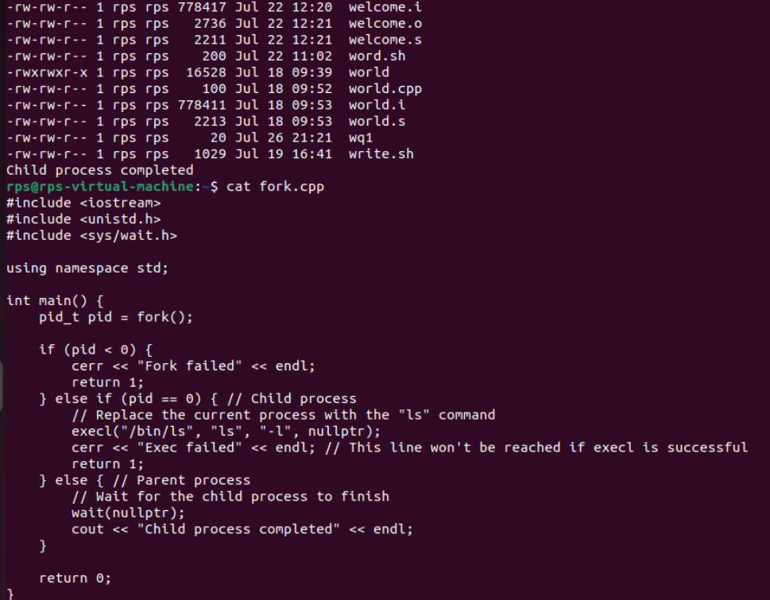

execvp function:

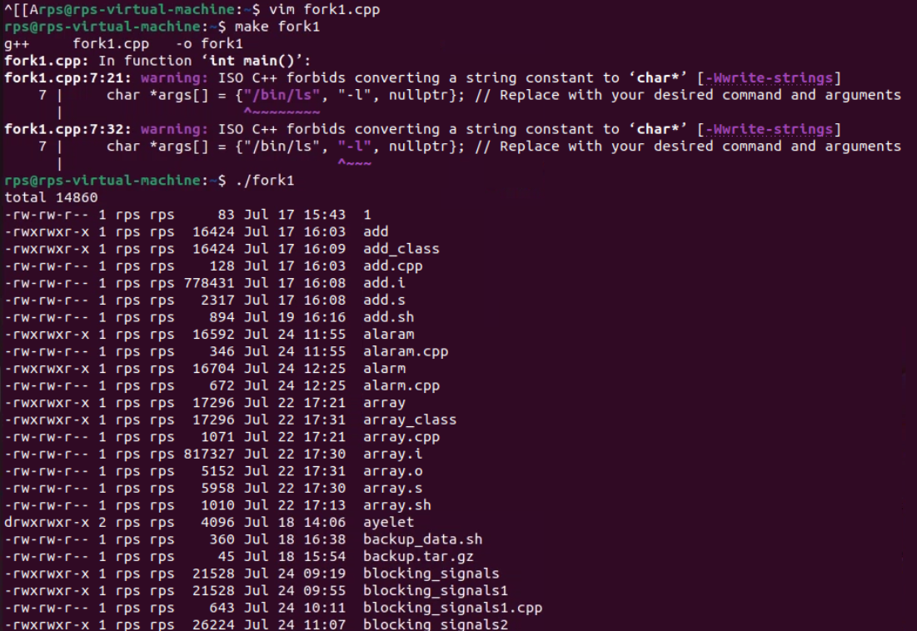

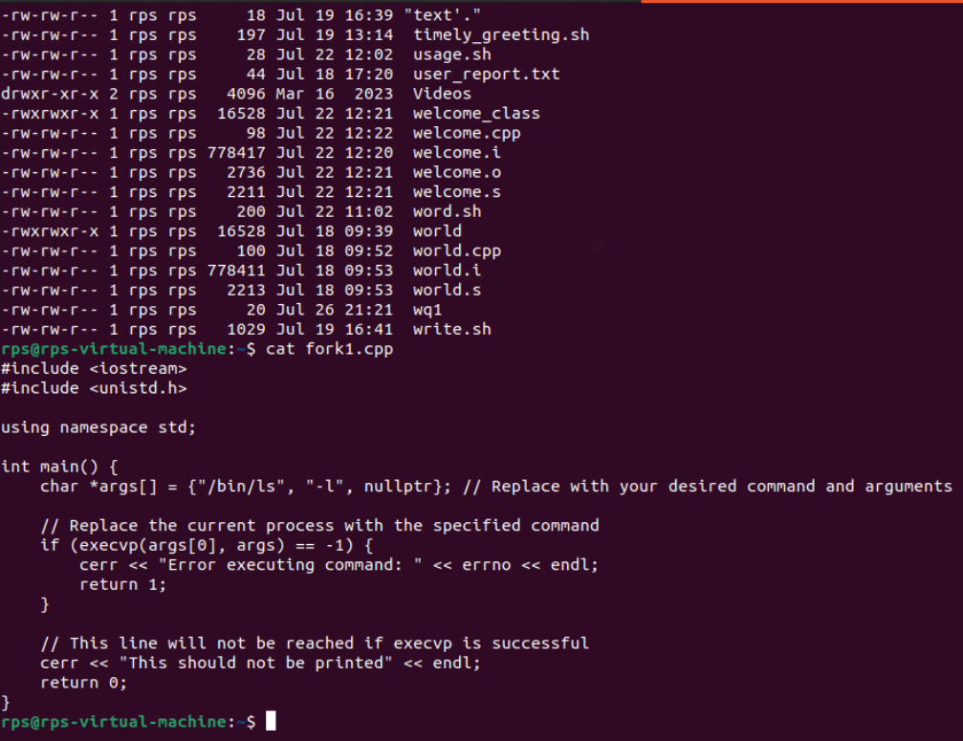

**child using fork while using execvp function**

